Ovo više nije običan dashboard nego puni Smart Grid Digital Twin Command Center.
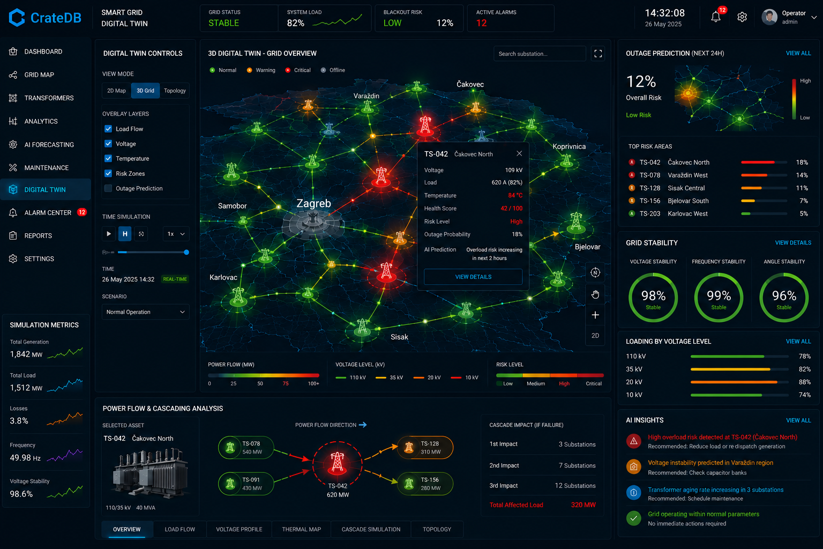
Prema slici koju smo generirali, ja bih Quasar aplikaciju organizirao ovako:

📁 Enterprise Structure
src/  ├── layouts/  │ └── MainLayout.vue  │  ├── pages/  │ ├── Dashboard.vue  │ ├── GridMap.vue  │ ├── Transformers.vue  │ ├── Analytics.vue  │ ├── Forecasting.vue  │ ├── Maintenance.vue  │ ├── AlarmCenter.vue  │ └── DigitalTwin.vue  │  ├── components/  │  │ ├── digital-twin/  │ │  │ ├── TwinHeader.vue  │ ├── TwinControls.vue  │ ├── TwinMap.vue  │ ├── TwinRiskPanel.vue  │ ├── TwinGridStability.vue  │ ├── TwinLoadingPanel.vue  │ ├── TwinInsights.vue  │ ├── TwinSimulationMetrics.vue  │ ├── TwinPowerFlow.vue  │ ├── TwinTopology.vue  │ └── TwinAssetDialog.vue  │  ├── stores/  │ ├── twinStore.js  │ ├── gridStore.js  │ ├── alarmStore.js  │ └── websocketStore.js  │  ├── services/  │ ├── websocket.js  │ ├── api.js  │ └── mqtt.js  │  └── router/  └── routes.js | 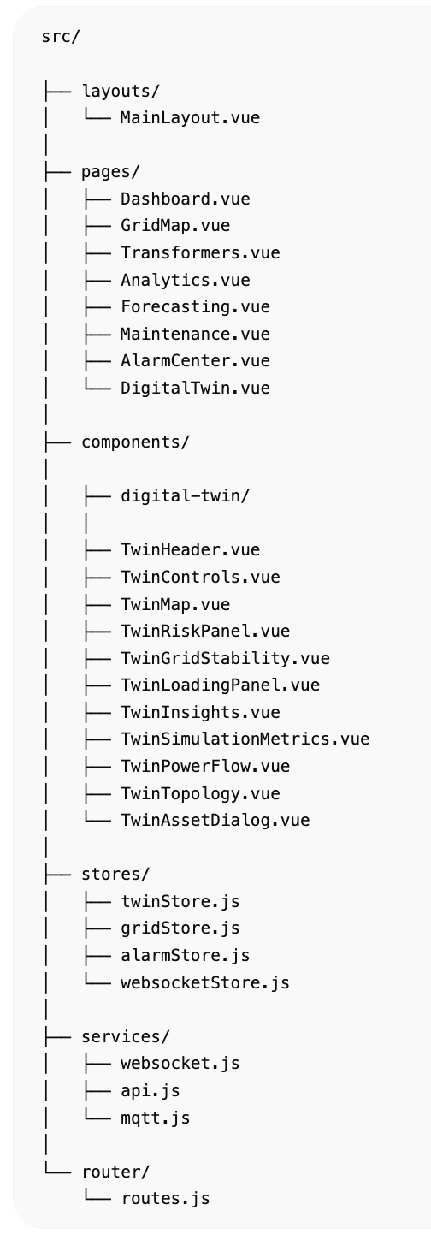

DigitalTwin.vue
Glavni ekran.
<template>  <q-page class="bg-dark text-white">  <TwinHeader />  <div class="row">  <div class="col-2">  <TwinControls />  </div>  <div class="col-7">  <TwinMap />  <TwinPowerFlow />  </div>  <div class="col-3">  <TwinRiskPanel />  <TwinGridStability />  <TwinLoadingPanel />  <TwinInsights />  </div>  </div>  </q-page>  </template>  <script setup>  import TwinHeader from 'components/digital-twin/TwinHeader.vue'  import TwinControls from 'components/digital-twin/TwinControls.vue'  import TwinMap from 'components/digital-twin/TwinMap.vue'  import TwinPowerFlow from 'components/digital-twin/TwinPowerFlow.vue'  import TwinRiskPanel from 'components/digital-twin/TwinRiskPanel.vue'  import TwinGridStability from 'components/digital-twin/TwinGridStability.vue'  import TwinLoadingPanel from 'components/digital-twin/TwinLoadingPanel.vue'  import TwinInsights from 'components/digital-twin/TwinInsights.vue'  </script> | 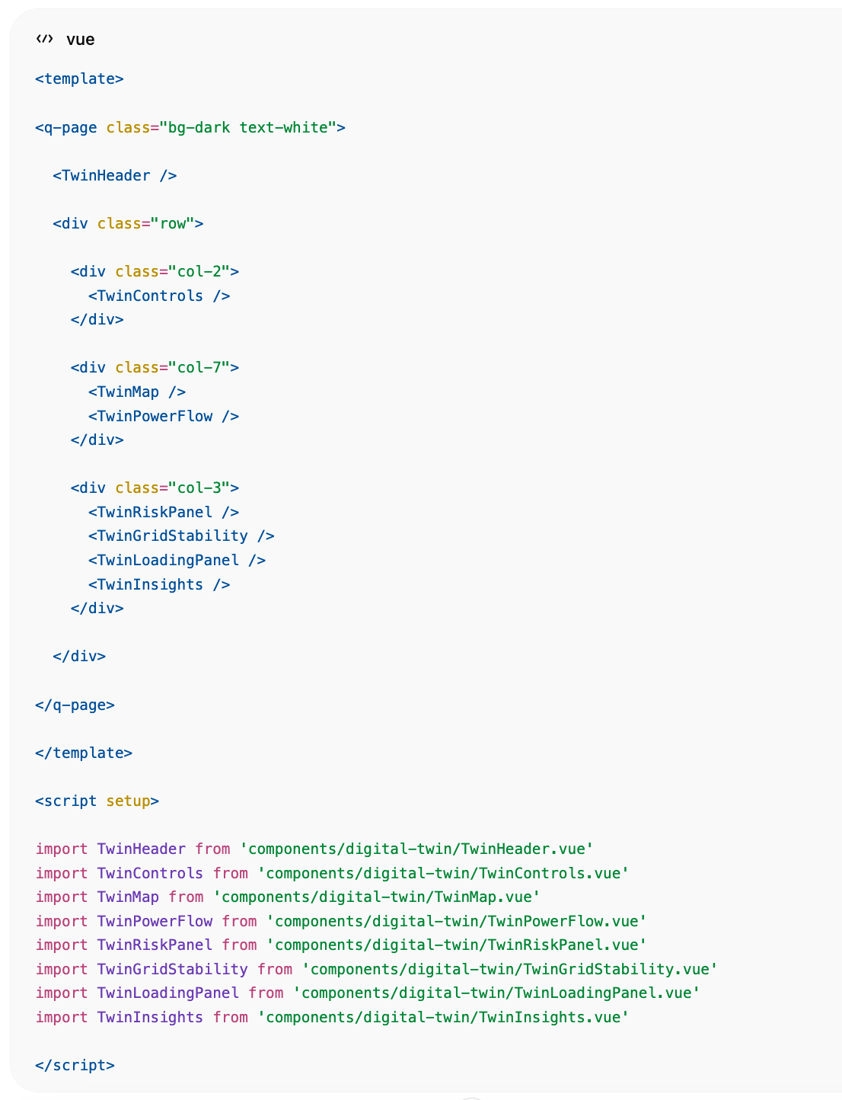

TwinHeader.vue
Gornji KPI panel.
<template>  <div class="row q-col-gutter-md q-pa-md">  <q-card dark class="col">  <q-card-section>  <div class="text-caption">  Grid Status  </div>  <div class="text-h5 text-green">  STABLE  </div>  </q-card-section>  </q-card>  <q-card dark class="col">  <q-card-section>  <div class="text-caption">  System Load  </div>  <div class="text-h5">  82%  </div>  </q-card-section>  </q-card>  <q-card dark class="col">  <q-card-section>  <div class="text-caption">  Blackout Risk  </div>  <div class="text-h5 text-orange">  12%  </div>  </q-card-section>  </q-card>  <q-card dark class="col">  <q-card-section>  <div class="text-caption">  Active Alarms  </div>  <div class="text-h5 text-red">  12  </div>  </q-card-section>  </q-card>  </div>  </template> | 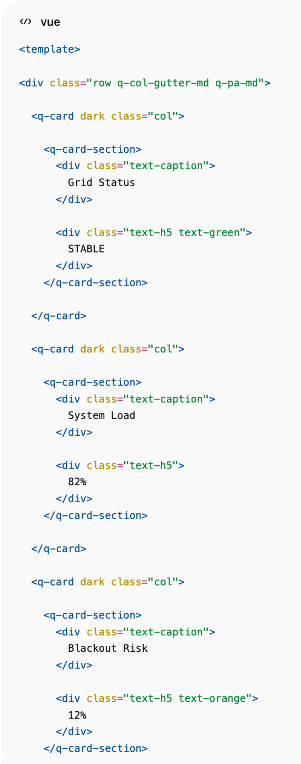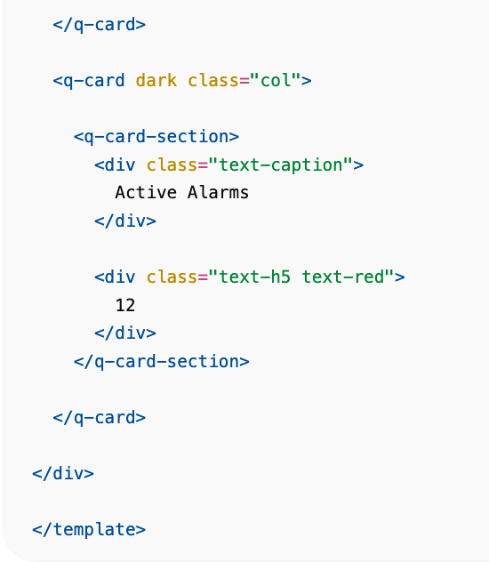

TwinControls.vue
Lijevi panel.
<template>  <q-card dark bordered>  <q-card-section>  <div class="text-h6">  Digital Twin Controls  </div>  </q-card-section>  <q-separator dark />  <q-card-section>  <q-btn-toggle  v-model="view"  toggle-color="primary"  :options="[  {label:'2D',value:'2d'},  {label:'3D',value:'3d'},  {label:'Topology',value:'topology'}  ]"  />  </q-card-section>  <q-card-section>  <q-checkbox v-model="layers.loadFlow" label="Load Flow" />  <q-checkbox v-model="layers.voltage" label="Voltage" />  <q-checkbox v-model="layers.temperature" label="Temperature" />  <q-checkbox v-model="layers.risk" label="Risk Zones" />  </q-card-section>  </q-card>  </template>  <script setup>  import { ref } from 'vue'  const view = ref('3d')  const layers = ref({  loadFlow:true,  voltage:true,  temperature:true,  risk:true  })  </script> | 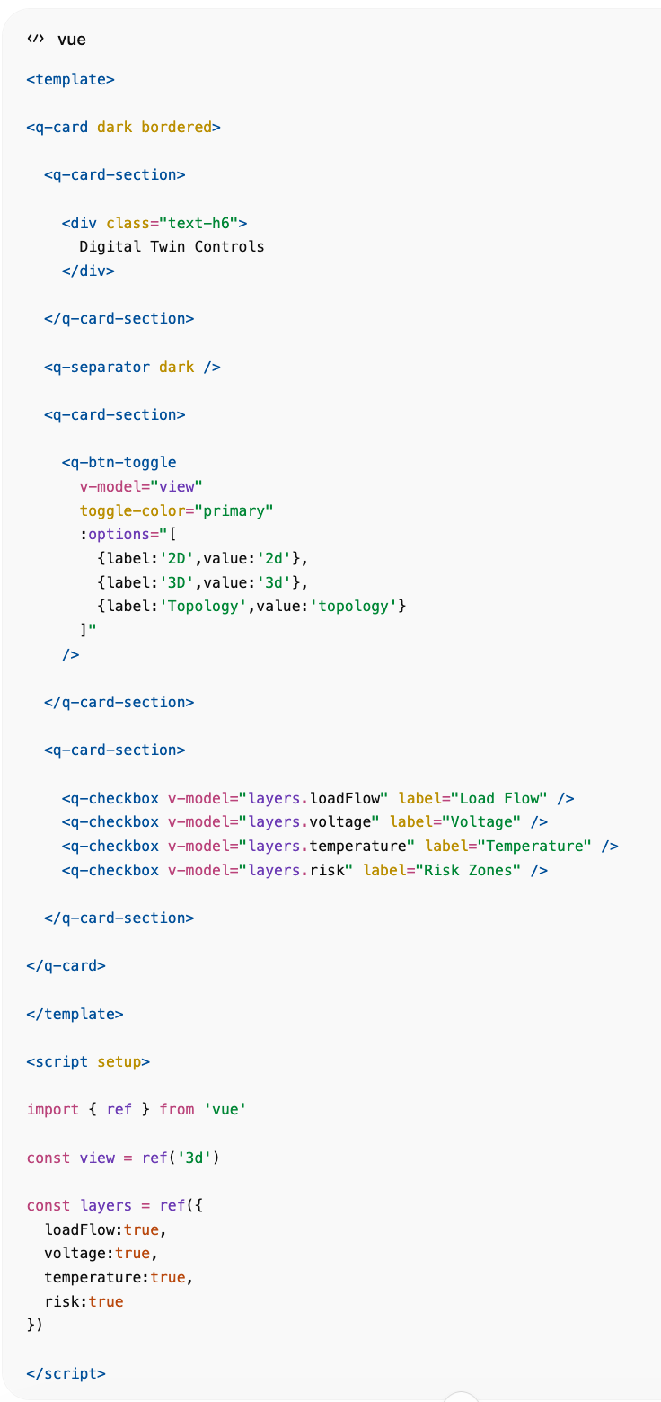

TwinMap.vue
Mapbox + DeckGL.
<template>  <q-card dark>  <q-card-section>  <div class="text-h6">  3D Digital Twin  </div>  </q-card-section>  <div id="map"></div>  </q-card>  </template>  <script setup>  import { onMounted } from 'vue'  import mapboxgl from 'mapbox-gl'  onMounted(() => {  mapboxgl.accessToken='TOKEN'  const map = new mapboxgl.Map({  container:'map',  style:'mapbox://styles/mapbox/dark-v11',  center:[16.433,46.385],  zoom:9  })  })  </script>  <style scoped>  #map{  height:700px;  }  </style> | 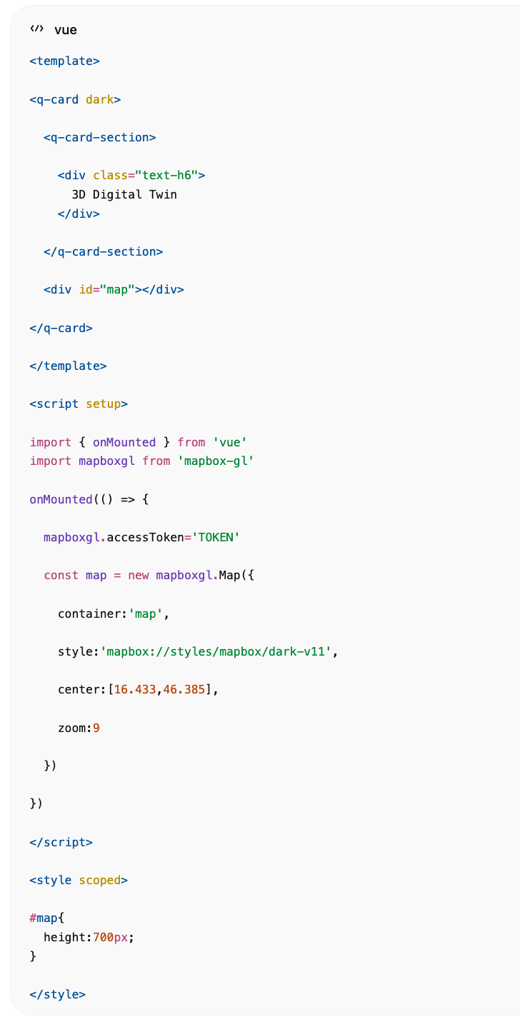

TwinRiskPanel.vue
Desni panel.
<template>  <q-card dark>  <q-card-section>  <div class="text-h6">  Outage Prediction  </div>  <div class="text-h2 text-orange">  12%  </div>  <div class="text-green">  LOW RISK  </div>  </q-card-section>  </q-card>  </template> | 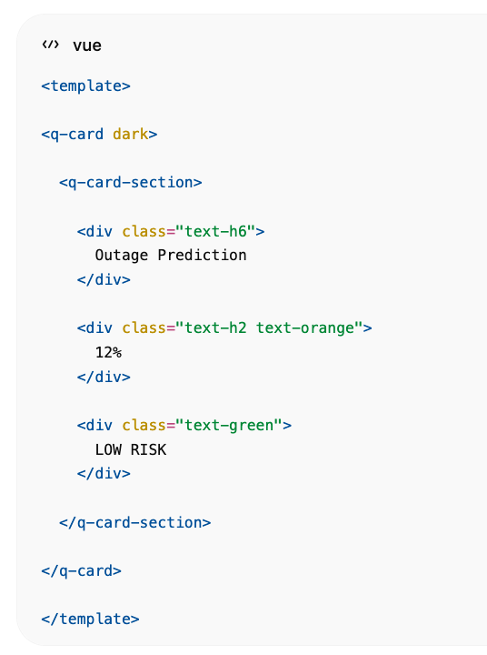

TwinGridStability.vue
<template>  <q-card dark>  <q-card-section>  <div class="text-h6">  Grid Stability  </div>  </q-card-section>  <q-card-section class="row justify-around">  <q-circular-progress  :value="98"  size="120px"  color="green"  show-value  >  98%  </q-circular-progress>  <q-circular-progress  :value="99"  size="120px"  color="green"  show-value  >  99%  </q-circular-progress>  </q-card-section>  </q-card>  </template> | 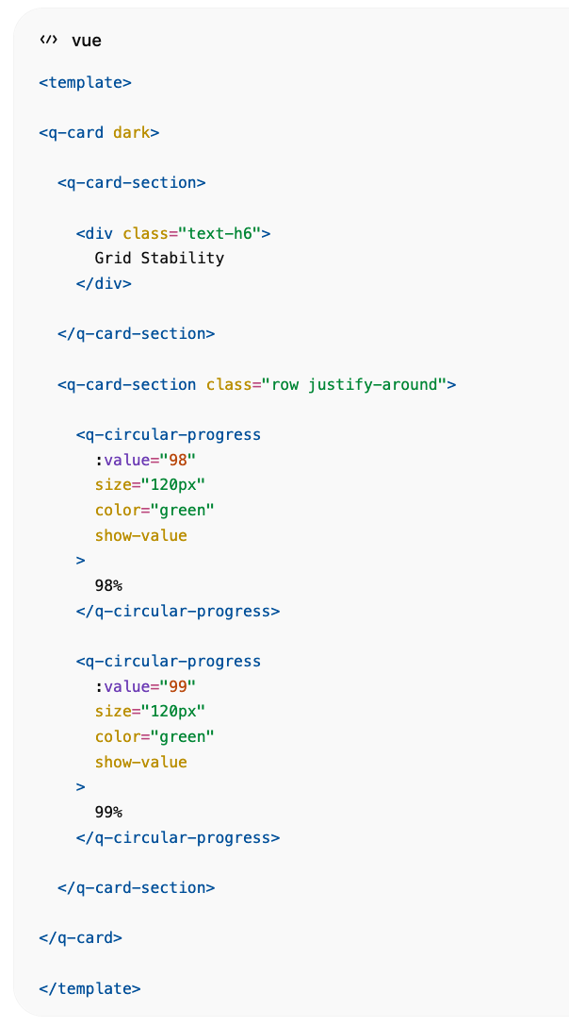

TwinPowerFlow.vue
Donji "Power Flow & Cascading Analysis"
<template>  <q-card dark>  <q-card-section>  <div class="text-h6">  Power Flow & Cascading Analysis  </div>  </q-card-section>  <div class="row">  <div class="col-4">  Transformer Preview  </div>  <div class="col-4">  Grid Flow Diagram  </div>  <div class="col-4">  Cascade Impact  </div>  </div>  </q-card>  </template> | 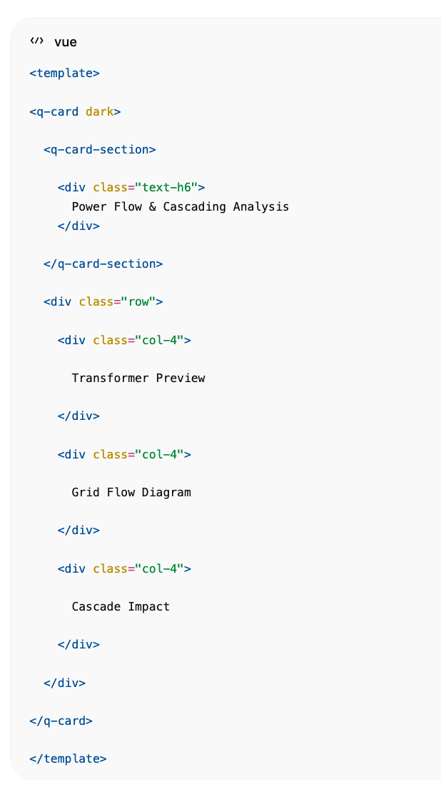

Pinia Store
// stores/twinStore.js  import { defineStore } from 'pinia'  export const useTwinStore = defineStore('twin', {  state: () => ({  gridStatus:'STABLE',  blackoutRisk:12,  activeAlarms:12,  selectedSubstation:null,  loadFlow:[],  topology:[],  riskAreas:[]  })  }) | 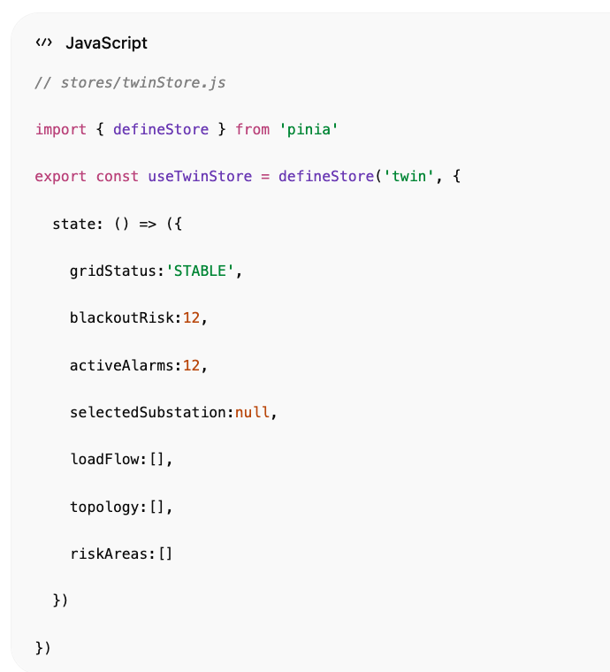

Realtime EMQX Feed
// services/websocket.js  const socket = new WebSocket(  'ws://localhost:8000/ws/grid'  )  socket.onmessage = (event)=>{  const data = JSON.parse(event.data)  twinStore.update(data) | 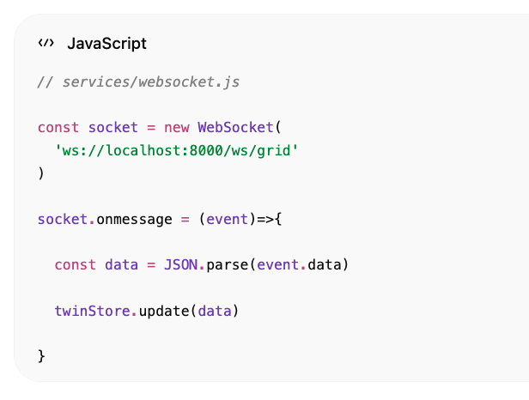

}

Enterprise Features za ovu stranicu

Digital Twin
- 2D GIS
- 3D GIS
- Network Topology
- Asset Twin

AI
- Load Prediction
- Blackout Prediction
- Cascading Failure Simulation
- Risk Scoring

Realtime
- MQTT → EMQX
- WebSocket
- CrateDB Live Queries

Visualization
- Mapbox
- DeckGL
- ECharts
- Three.js

Backend
- FastAPI
- CrateDB
- EMQX
- PyTorch AI Services
To je praktički ista arhitektura i UX kakvu bi koristio CrateDB demo za elektrodistribucije ili utility operatore.

